Notes to the Photo album and photographs of Cactaceae from Carlos Spegazzini in the Herbarium of the Museum of Pharmacobotany “Juan A. Domínguez” (BAF), Faculty of Pharmacy and Biochemistry, University of Buenos Aires, Buenos Aires, Argentina.

Fabián Font

The photo album of Carlos Spegazzini and other photographs were published as a semi-facsimile edition (Font, 2016), and it can be viewed online in the website of the publication in pharmacobotany Dominguezia:
[http://www.dominguezia.org/volumen/index.php?Mostrar=32(1)].
Here, supplementary notes about the photos are presented. Some other differences in the presentation edition of both publications are explained in the introduction Dominguezia.

Nomenclatural update of each name has been discarded for the simple reason that the current profusion of revisions in the nomenclature of the cactus family is never-ending. The lists of published synonyms and new combinations far exceed the individual work that any botanist can perform when attempting a nomenclatural update of the entire plant family. Fortunately there is a very quick way to verify each name by choosing any of the botanical world data banks that are updated periodically as IPNI (http://ipni.org/ipni/plantnamesearchpage.do), Tropicos (http://www.tropicos.org/NameSearch.aspx) or any catalog of "official" online Flora of each country.

Each page of the album is described in an Excel spreadsheet [ICONES.xlsx] which is made as follows:
- There are three sheets:
  - EN: English.
  - FR: French.
  - SP: Spanish.
- Column A: Page number; missing pages correspond to blank pages. Only page numbers 1-148 show pictures from the album of Spegazzini. Page numbers above 148 are other unpublished pictures that were not in the album; however, they were owned by Spegazzini and are now available from BAF.
- Columns B, C and D (Layout): the photo arrangement and numbering on the page under consideration. Each photo is attributed a different number.
- Column F (Photo): photo number. NB: Page and photo numbers are those used in Dominguezia.
- Column H (Annotations…): transcription of the annotations found either on the front side ["F" in column G] or the back side ["B" in column G] of the photo [number in column F]. These annotations are corrected for some mistakes that appear in Dominguezia article.
- Column I (Author): author of the photo. They can be:
Bruch = Carlos Bruch
Arech. = José Arechavaleta
Franck = Albert Harry Franck
Speg. = Carlos Spegazzini
? = unknown author
- Column J (Handwriting): author of the annotations or label. Most often Spegazzini, but not always.
- Column K (Published in): reference to the publication (see bibliography below) where the picture was first published. In some of these publications, the picture is designated as the nomenclatural type.
- Column L: Further comments.

Bibliography cited in the spreadsheet:
Arechavaleta, J. [1902] (1905). Flora Uruguaya. Cactáceas. An. Mus. Hist. Nat. Montevideo 5(2): 161-291. http://www.biodiversitylibrary.org/item/37104 - page/13/mode/1up
Britton, N. L. & Rose, J. N. (1919). The Cactaceae. Descriptions and illustrations of plants of the cactus family. Vol. I: 1-236. Carnegie Institution, publ. 248. Washington. https://www.cactuspro.com/biblio/fr:britton_et_rose
Britton, N. L. & Rose, J. N. (1920). The Cactaceae. Descriptions and illustrations of plants of the cactus family. Vol. II: 1-241. Carnegie Institution, publ. 248. Washington. https://www.cactuspro.com/biblio/fr:britton_et_rose
Britton, N. L. & Rose, J. N. (1922). The Cactaceae. Descriptions and illustrations of plants of the cactus family. Vol. III: 1-258. Carnegie Institution, publ. 248. Washington. https://www.cactuspro.com/biblio/fr:britton_et_rose
Crook, R. & Mottram, R. (1995). Opuntia Index. Part 1: Nomenclatural note and A-B. Bradleya 13: 88-118.
Crook, R. & Mottram, R. (1996). Opuntia Index. Part 2: Nomenclatural note and C-E. Bradleya 14: 99-14
Font, F. (2016). Carlos Spegazzini: Icones Cactacearum. Álbum y fotografías de Cactáceas del Dr. Carlos Spegazzini en el Herbario del Museo de Farmacobotánica “Juan A. Domínguez” (BAF), Facultad de Farmacia y Bioquímica, Universidad de Buenos Aires, Buenos Aires, Argentina. Dominguezia 32 (1).
http://www.dominguezia.org/volumen/index.php?Mostrar=32(1)
Katinas, L., Gutiérrez, D. G. & Torres Robles, S. S. (2000). Carlos Spegazzini (1858-1926): Travels and botanical work on vascular plants. Annals of the Missouri Botanical Garden 87 (2):183-202. http://www.biodiversitylibrary.org/item/86338/page/189/mode/1up
Katinas, L. Gutiérrez, D. G. & Torres Robles, S. S. (2004). Type material of Carlos L. Spegazzini in the Museo de La Plata herbarium (LP), Argentina. III: Cactaceae. Darwiniana 42(1-4): 177-200.
http://www.ojs.darwin.edu.ar/index.php/darwiniana/article/view/176/163
Kiesling, R. (1984). Recopilación, en edición facsimilar, de todos los trabajos o referencias sobre Cactáceas publicadas por el Dr. Carlos Spegazzini. Librosur, Quilmes, Argentina. https://www.cactuspro.com/biblio/fr:kiesling - cactaceas_publicadas_por_el_dr_carlos_spegazzini
Kiesling, R. (1998). Nota sobre Opuntia anacantha Speg. (Cactaceae) para la flora de Paraguay y Argentina. Candollea 53: 471-476.
Kiesling, R. (1999). Nuevos sinónimos de Opuntia ficus-indica (Cactaceae). Hickenia 2 (66): 309-314.
Kiesling, R. Metzing, D. (1996). Una nueva combinación en Gymnocalycium (Cactaceae). Darwiniana 34 (1-4): 402-404.
http://www.ojs.darwin.edu.ar/index.php/darwiniana/article/view/430/419
Lanteri, A. A. & Martínez, A. (2012). Carlos Bruch: pionero de los estudios entomológicos en la Argentina. Rev. Soc. Entomol. Argent. 71 (3-4): 179-185.
http://www.scielo.org.ar/pdf/rsea/v71n3-4/v71n3-4a01.pdf
Merelli, C. A. (1926). Cantero de Cactáceas. Informaciones del Jardín Zoológico de La Plata 2(1): 49-52.
Molfino, J. F. (1929). Carlos Spegazzini. Su vida y su obra. An. Soc. Cient. Arg. 108: 7-77. http://www.biodiversitylibrary.org/item/192625 - page/17/mode/1up
Molfino, J. F. (1951). Semblanza del Doctor Carlos Spegazzini. Com. Cient. Museo de La Plata, nº2: 1-6.
Spegazzini, C. (1901). Contribución al estudio de la Sierra de Tandíl. XX. Cactaceas. 17-19. La Plata. http://www.biodiversitylibrary.org/item/37833 - page/5/mode/1up
Spegazzini, C. (1905). Cactacearum Platensium Tentamen. An. Mus. Nac. Buenos Aires 11, 3ª Sº (4): 477-521. (See Kiesling, 1984)
Spegazzini, C. (1921). Plantas nuevas o interesantes. An. Soc. Cient. Arg. 92:118-120. http://www.biodiversitylibrary.org/item/97814 - page/370/mode/1up
Spegazzini, C. (1923). Breves notas cactológicas. An. Soc. Cient. Arg. 96:61-75. http://www.biodiversitylibrary.org/item/193056 - page/367/mode/1up
Spegazzini, C. (1925). Nuevas notas cactológicas. An. Soc. Cient. Arg. 99:85-156. http://www.biodiversitylibrary.org/item/192649 - page/105/mode/1up

Abbreviations
BAF: Herbarium Facultad de Farmacia y Bioquímica, Museo de Farmacobotánica Juan A. Domínguez, University of Buenos Aires
LP: Herbarium of the División Plantas Vasculares of Museo de La Plata.

Index
Pages 1-148 covers the album of Spegazzini. Pages numbers above 148 present other photos of Spegazzini's collection (See introdution in Dominguezia).
Photos without annotations have been attributed a tentative name that is followed by (*).

Plant name Page
Arequipa leucotricha 1
Astrophytum myriostigma 3
Astrophytum ornatus 3
Aylostera pseudominuscula 5
Brittonrosea gladiata 7
Cactus melocatus 9
Cereus dusenii 162
Cereus aethiops 11
Cereus alacriportanus 12
Cereus baumannii 21
Cereus candicans 13
Cereus coerulescens 11
Cereus dayami 14, 173
Cereus guelichii 69
Cereus lamprochlorus 15
Cereus macdonaldiae 139
Cereus platygonus 17
Cereus pomanensis 71
Cereus roseiflorus 157
Cereus smaragdiflorus 21
Cereus spachianus 171
Cereus spegazzinii 17
Cereus thelegonoides 147
Cereus thelegonus 148
Chamaecereus silvestrii 19
Cleistocactus (*) 115
Cleistocactus baumannii 21
Cleistocactus smaragdiflorus 21
Denmoza rhodacantha 23
Echinocactus arechavaletai 89
Echinocactus baldianus 60
Echinocactus bicolor 143
Echinocactus caespitosus 53
Echinocactus ceratistes 47
Echinocactus chionanthus 77
Echinocactus chrysacanthus 49
Echinocactus clavatus 1
Echinocactus coptogonus 49
Echinocactus corniger 50
Echinocactus cylindraceus 49
Echinocactus denudatus 33
Echinocactus emoryii var. rubrispina 50
Echinocactus erinaceus 86
Echinocactus exculptus 111
Echinocactus famatimensis 78
Echinocactus gibbosus 56
Echinocactus gibbosus var. typica 56, 57
Echinocactus gibbosus var. ventanicola 56
Echinocactus gracillimus 53
Echinocactus grahlianus 53
Echinocactus grusonii 25
Echinocactus haematanthus 79
Echinocactus haselbergii 87
Echinocactus heterochromus 144
Echinocactus hyalinacanthus 78
Echinocactus ingens 25
Echinocactus lenninghausii 87
Echinocactus leucacanthus 9
Echinocactus longihamatus 50
Echinocactus lophothele 143
Echinocactus loricatus 58
Echinocactus macrodiscus 50
Echinocactus mammulosus var hircina 88
Echinocactus mammulosus var. pampena 88
Echinocactus melocactus 9
Echinocactus microspermus var. erytrantha 131
Echinocactus microspermus var. thionantha 132
Echinocactus minusculus 9
Echinocactus monvillei 58, 65
Echinocactus myriostigma 3
Echinocactus nidus 111
Echinocactus nigrispinus 89
Echinocactus odieri 53
Echinocactus orcutti 51
Echinocactus ornatus 3
Echinocactus ottonis 9, 89
Echinocactus pilosus 51
Echinocactus platensis var. leptantha 60
Echinocactus platensis var. parvula 60
Echinocactus platensis var. quehliana 60
Echinocactus platensis var. typica 60
Echinocactus pumilus 9
Echinocactus pygmaeus 54
Echinocactus quehlianus 25
Echinocactus recurvus 51
Echinocactus robustus 51
Echinocactus saglione 63
Echinocactus schickendantzii 63
Echinocactus schilinzkyanus 54
Echinocactus schumannianus 92
Echinocactus scopa candida 91
Echinocactus setispinus 67
Echinocactus simpsonii var. 130
Echinocactus soehrensii 91
Echinocactus stellatus 61
Echinocactus stuckertii 65
Echinocactus submammulosus 89
Echinocactus tellii 7
Echinocactus texensis 73
Echinocactus turbiniformis 142
Echinocactus uncinatus var. wrigthii 52
Echinocactus viridescens 52
Echinocactus williamsi 72
Echinocactus wislizeni 52
Echinocereus bradegeei 27
Echinocereus chloranthus 28
Echinocereus cinerascens 28
Echinocereus coccineus 31
Echinocereus dasyacanthus 27
Echinocereus dubius 27
Echinocereus engelmannii var. 28
Echinocereus enneacanthus 29
Echinocereus knippelianus 29
Echinocereus maritimus 29
Echinocereus pacificus 30
Echinocereus papillosus 30
Echinocereus paucispinus 30
Echinocereus pectinatus var. armata 30
Echinocereus polyacanthus 31
Echinocereus pulchellus var. amoena 31
Echinocereus roetteri 31
Echinocereus salm-dykianus 32
Echinocereus sandleri 101
Echinocereus sciurus 32
Echinocereus subinermis 32
Echinocereus viridiflorus 32
Echinomastus erectocentrus 33
Echinopsis (*) 35
Echinopsis ancistrophora 35
Echinopsis calochlora 35
Echinopsis campilacantha 37
Echinopsis campilacantha var. aurea 37
Echinopsis cinnabarina 78
Echinopsis eyriesii 35, 37
Echinopsis forbesii 36
Echinopsis formosissima 36
Echinopsis gemmata var. alba 45
Echinopsis intrincatissima 38
Echinopsis leucantha (*) 24
Echinopsis leucantha 37, 42
Echinopsis leucantha aurea 38
Echinopsis minuana 38
Echinopsis mirabilis 39
Echinopsis molesta 40
Echinopsis multiplex cristata 39
Echinopsis oxygona 40, 41
Echinopsis pentlandii var. longispina 80
Echinopsis pseudominuscula 5
Echinopsis rhodotricha 42
Echinopsis silvestrii 43
Echinopsis spegazziniana 38
Echinopsis tubiflora 43, 44
Echinopsis turbinata 45
Echinopsis valida 36
Eryiosyce ceratistes 47
Ferocactus acanthodes 49
Ferocactus chrysacanthus 49
Ferocactus coptonogonus 49
Ferocactus emoryii var. rubrispina 50
Ferocactus hamatacanthus 50
Ferocactus longispinus 50
Ferocactus macrodiscus 50
Ferocactus nobilis 51
Ferocactus orcutti 51
Ferocactus pringlei 51
Ferocactus robustus 51
Ferocactus uncinatus var. wrigthii 52
Ferocactus viridescens 52
Ferocactus wislizeni 52
Frailea (Echinocactus) gracillimus 53
Frailea (Echinocactus) grahlianus 53
Frailea (Echinocactus) minusculus 9
Frailea (Echinocactus) pumilus 9
Frailea caespitosa 53
Frailea odieri 53
Frailea phaeodisca 54
Frailea pygmaea 54
Frailea schilinzkyana 54
Gymnocalycium chubutense [dibujo] 160
Gymnocalycium damsii 55
Gymnocalycium denudatus 33
Gymnocalycium gibbosum var. typica 56, 57
Gymnocalycium gibbosum var. ventanicola 56
Gymnocalycium gibbosus 56
Gymnocalycium loricatum 58
Gymnocalycium monvillei 58
Gymnocalycium multiflorum 59
Gymnocalycium platense 25, 60
Gymnocalycium platense var. baldiana 60
Gymnocalycium platense var. leptantha 60
Gymnocalycium platense var. parvula 60
Gymnocalycium platense var. quehliana 60
Gymnocalycium platense var. stellata 61
Gymnocalycium schickendantzii 64
Gymnocalycium spegazzinii 58
Gymnocalycium stuckertii 65
Gymnocalycium uruguayense 65
Gymnocalycium sanjuanense 63
Gymnocalycuin saglionis 63
Hamatocactus setispinus 67
Harrisia guelichii 69
Harrisia martinii 70
Harrisia pomanensis 71
Homalocephala texensis 73
Hylocereus (*) 114
Lobivia (Echinocactus) bruchii 74
Lobivia (Echinopsis) cinnabarina 78
Lobivia (Echinopsis) pentlandii var. longispina 80
Lobivia andalgalensis 75
Lobivia cachensis 77
Lobivia chionantha 77
Lobivia chrysantha 81
Lobivia famatimensis 78
Lobivia haematantha 79
Lobivia hyalinacantha 78
Lobivia hyalacantha 159
Lobivia oreopepon 79
Lobivia saltensis 80
Lobivia shaferi 81, 172
Lobivia shaferi f. brachyacantha 172
Lobivia thionantha 81
Lophophora williamsi 72
Maihuenia tehuelches 107
Maihuenia valentini 107
Mala(co)carpus ottonis 9
Malacocarpus catamarcensis 85
Malacocarpus concinnus 85
Malacocarpus erinaceus 86, 87
Malacocarpus haselbergii 87
Malacocarpus lenninghausii 87
Malacocarpus mammillosus var. hircina 88
Malacocarpus mammulosus (*) 89
Malacocarpus mammulosus var. pampena 88
Malacocarpus mammulosus var. submammulosa 89
Malacocarpus mammulosus var. typica 87
Malacocarpus nigrispinus 89
Malacocarpus ottonis 89, 90
Malacocarpus ottonis var. tenuispina 90
Malacocarpus pampeanus 88
Malacocarpus schumannianus 92
Malacocarpus scopa 91
Malacocarpus soehrensii 91
Malacocarpus submammulosus 89
Malacocarpus tabularis 92
Malacocarpus tephracanthus 93
Malacocarpus tephracanthus var. macracantha 93
Mam(m)illaria halei 100
Mamillaria 104
Mamillaria angularis 95
Mamillaria bicolor 95
Mamillaria bocasana 95
Mamillaria candida 96
Mamillaria cantricirrha 96
Mamillaria celsiana 96
Mamillaria cornifera 96
Mamillaria cornuta 97
Mamillaria coronaria 97
Mamillaria dolichocentra 97
Mamillaria elegans 98
Mamillaria elephantidens 97
Mamillaria elongata 98
Mamillaria gigantea 99
Mamillaria glochidiata 98
Mamillaria gracilis 94
Mamillaria grahamii 99
Mamillaria heyderi 99
Mamillaria karwinskiana 100
Mamillaria leona 100
Mamillaria leucocentra 100
Mamillaria longimamma 98
Mamillaria macromeris 101
Mamillaria macrothele 106
Mamillaria meonacantha 102
Mamillaria micromeris 101
Mamillaria mutabilis 102
Mamillaria nivosa 102
Mamillaria parkinsonii 102
Mamillaria plumosa 103
Mamillaria poselgeri 103
Mamillaria pusilla 103
Mamillaria pycnacantha 103
Mamillaria radians 104
Mamillaria radiosa 104
Mamillaria raphidacantha 104
Mamillaria recurvata 104
Mamillaria rhodantha 101
Mamillaria scheeri 105
Mamillaria schelhasei 105
Mamillaria senilis 105
Mamillaria sphacelata 105
Mamillaria spinossisima 106
Mamillaria trohartii 106
Mamillaria wildii 94
Mamillaria zephyranthoides 106
Mamillaria haley 100
Monvillea cavendishii 109
Monvillea spegazzinii 109
Neoporteria exculptus 111
Neoporteria nidus 111
Neoporteria nigricans 111
Nopalxochia phyllanthoides 112
Opuntia 127
Opuntia 115
Opuntia 114
Opuntia (*) 113
Opuntia anacantha 117
Opuntia arechavaletae 117
Opuntia argentina 117
Opuntia aurantiaca 127
Opuntia bonaerensis 119, 149
Opuntia bonariensis 119, 149
Opuntia chaquensis 119, 151
Opuntia chakensis 150, 151
Opuntia cordobensis 121
Opuntia darwinii 169
Opuntia ficus-indica 122
Opuntia ficus-indica var. decumana 122
Opuntia glomerata 153
Opuntia halophila 152
Opuntia hickeni 164
Opuntia molinensis 154
Opuntia nigrispina 168
Opuntia pentlandii 167
Opuntia quimilo 123
Opuntia retrorsa 123
Opuntia russellii 165
Opuntia salmiana 125
Opuntia schickendantzii 126
Opuntia subsphaerocarpa 155
Opuntia tuna-blanca 156
Opuntia verschaffeltii var. digitalis 127
Opuntia weberi 128
Parodia brasiliensis 132
Parodia microsperma erytrantha 131
Parodia microsperma var. erytrantha f. leptacantha 131
Parodia microsperma var. ischirancistra 166
Parodia microsperma var. thionantha 132
Pediocactus simpsonii var. 130
Phyllocactus phyllanthoides 112
Pilocereus pasacana 146
Pilocereus rhodacanthus 23
Pilocereus terscheckii 170
Pterocactus 161
Pterocactus kuntzei 133
Pterocactus tuberosus 133
Rebutia (Echinopsis) minuscula 137
Rebutia pseudominuscula 5
Rhipsalis cereuscula 135
Rhipsalis houlletiana 136
Selenicereus macdonaldiae 139
Sterealya pseudominuscula 5
Stetsonia coryne 141
Strombocacus turbiniformis 142
Tephrocactus hickeni 164
Tephrocactus platyacanthus 163
Thelocactus bicolor 143
Thelocactus lophothele 143
Thelocactus pottsii 144
Trichocereus pasacana 146, 158
Trichocereus spachianus 171
Trichocereus terscheckii 170
Trichocereus thelegonoides 147
Trichocereus thelegonus 148

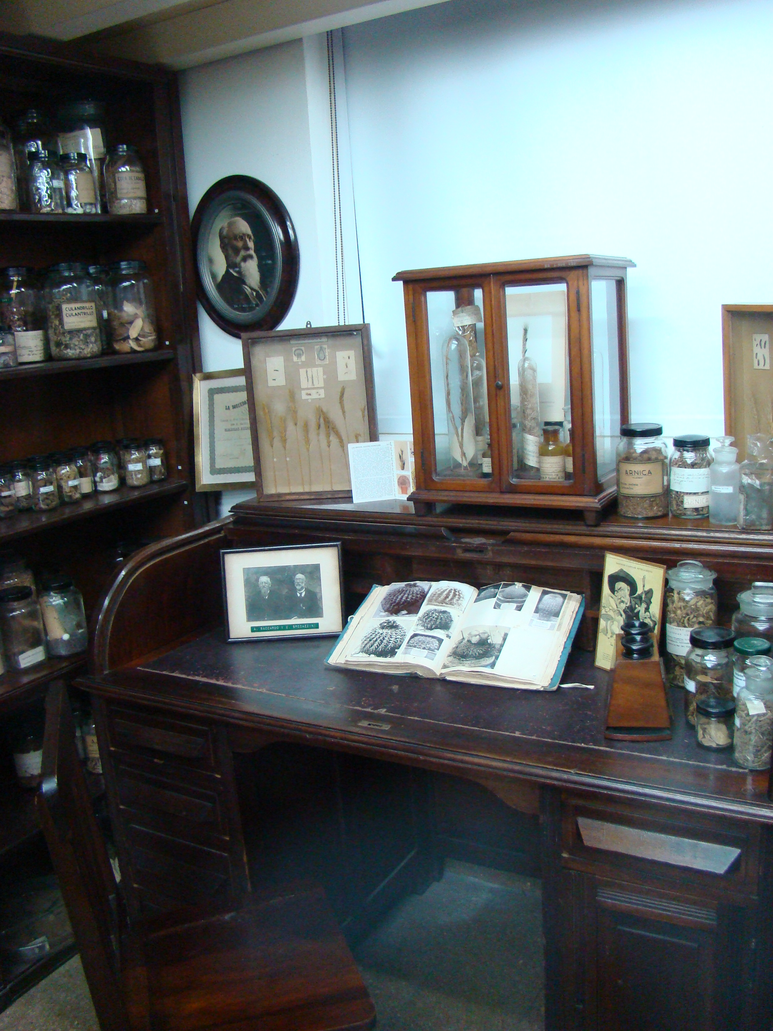
Cabinet in homage to Carlos Spegazzini in the Museum of Pharmacobotany "Juan Aníbal Domínguez", FFyB UBA.
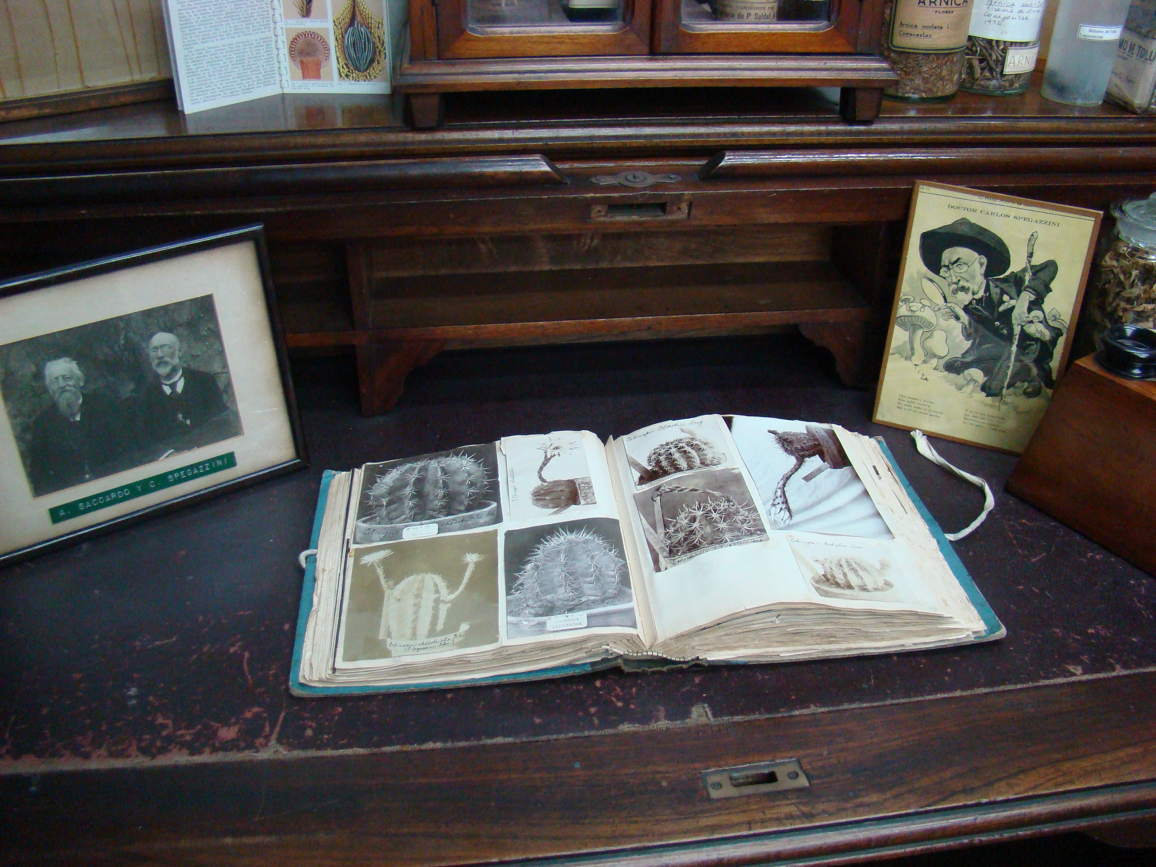
Icones Cactacearum, the personal album of cacti made by Carlos Spegazzini.

Museo de Farmacobotánica “Juan A. Domínguez” (BAF), Facultad de Farmacia y Bioquímica, Universidad de Buenos Aires. Junín 956 (1113). Ciudad Autónoma de Buenos Aires, Argentina.E-mail: ffont@ffyb.uba.ar, fabfont@hotmail.com

